Calm App: <https://apps.apple.com/us/app/calm/id571800810>

Melodies for Sleep: <https://apps.apple.com/us/app/relax-melodies-sleep-sounds/id314498713>

Sleep Sounds: <https://apps.apple.com/us/app/sleep-sounds-by-sleep-pillow/id410606661>

Coloring: <https://apps.apple.com/us/app/lake-coloring-books/id1183717726>

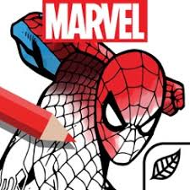 Coloring: <https://apps.apple.com/us/app/marvel-color-your-own/id1136343771>

Coloring: <https://apps.apple.com/us/app/recolor-coloring-book-to-color/id1027352017>

ZOOM App: <https://apps.apple.com/us/app/zoom-cloud-meetings/id546505307>